**PCTU Trade Up/In place upgrade ticket**

1. The following eform template needs to be used going forward for any PCTU Trade Up/In place upgrade ticket Click: [PC Trade Up Request Form](https://apc01.safelinks.protection.outlook.com/?url=https%3A%2F%2Fpgglobalenterprise.service-now.com%2FITSM_Portal%2Fcatalog-item.do%3Fsysparm_document_key%3Dsc_cat_item%2C79a986a8db8d84d4766be6650596198b&data=02%7C01%7Cshweta-j%40hcl.com%7C468dd3e23b56468fb5f008d7b523c8f3%7C189de737c93a4f5a8b686f4ca9941912%7C0%7C0%7C637177037798224419&sdata=GiMb8F3hkd5tsT0D9eSmal3G92Pu%2FcksGAgepUI5ihw%3D&reserved=0)
2. Steps to fill in information below: Requested for is customer name

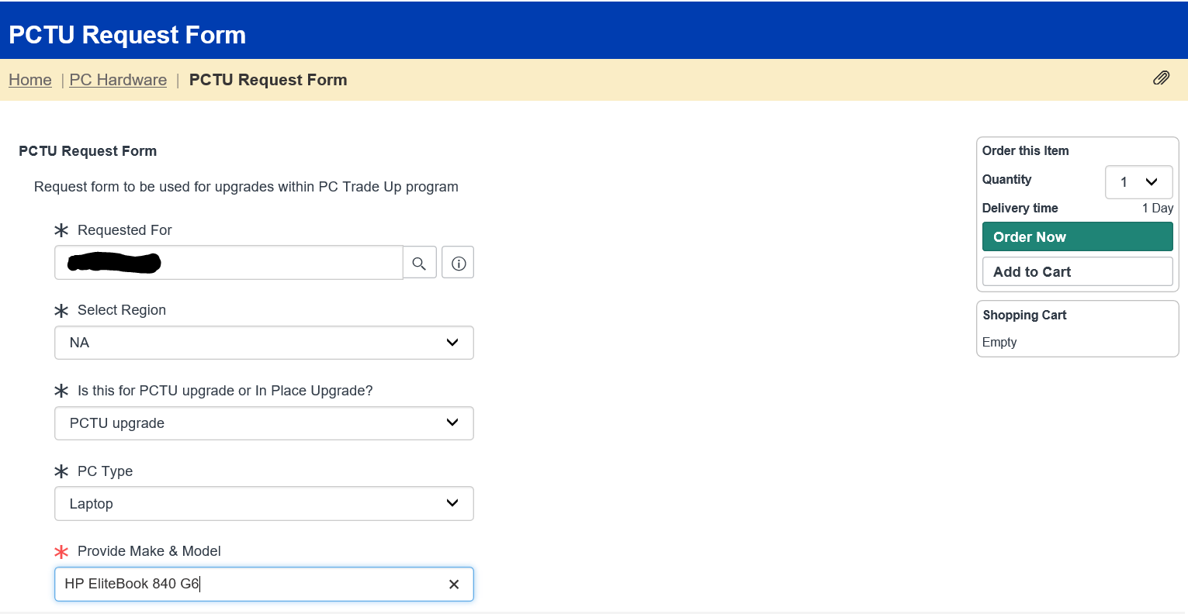

1. Click Order Now: Will create a Request Number:

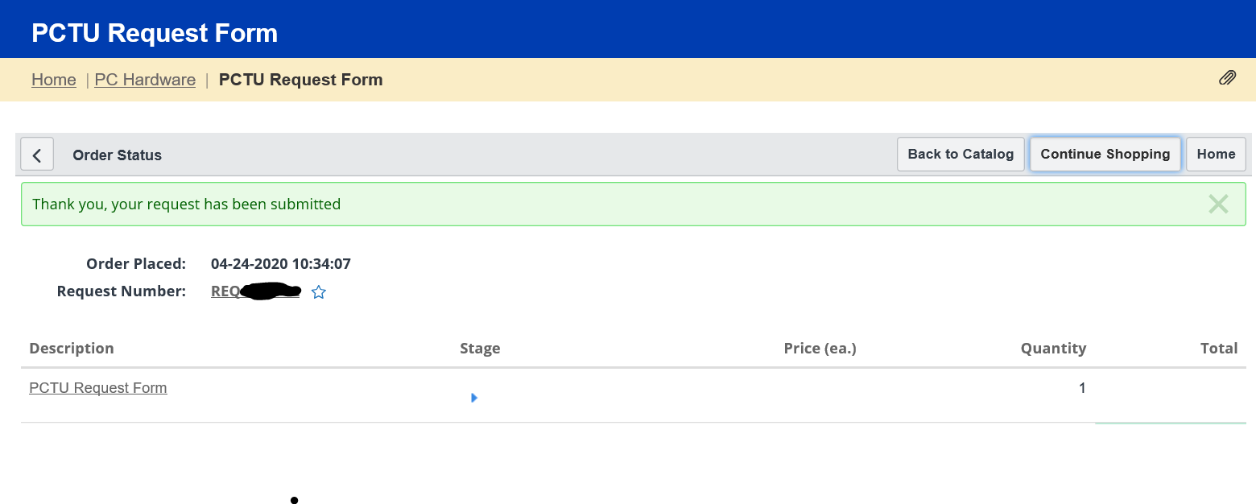

1. Click on PCTU Request Form
2. In Description field:
   1. Customer short name + scheduled Date
   2. Old Model/Serial number
   3. New Serial Number